**How to configure SQL Workbench with Amazon Redshift**

* Summary of steps required

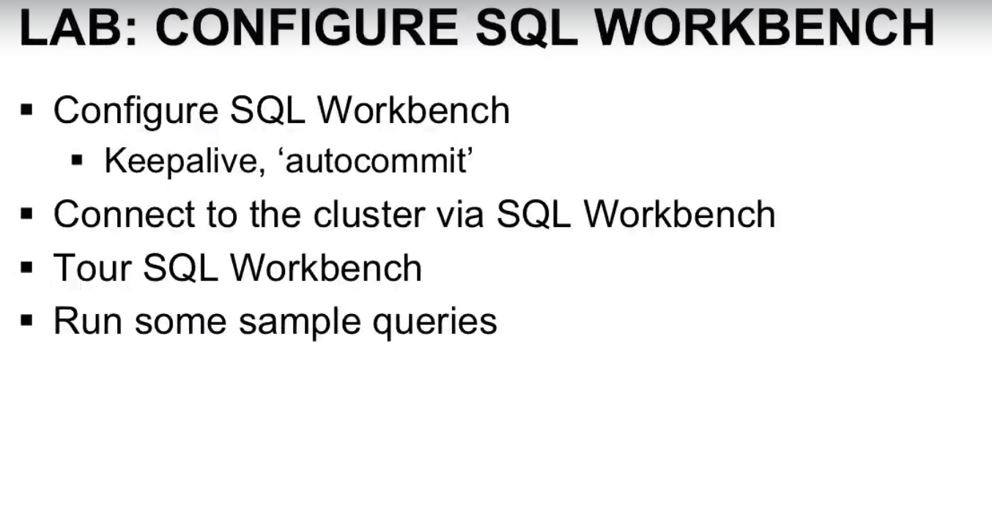

**Step1- Download the jdbc driver**

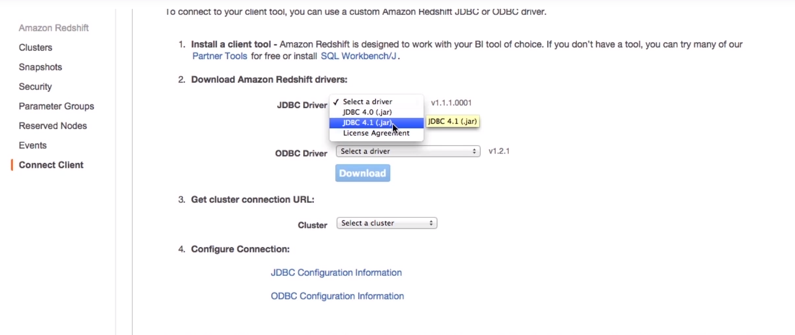

Step2- Install SQL Workbench

<http://www.sql-workbench.eu/>

Note- SQL workbench and MYSQL Workbench are completely different

Step3-

* Open SQL Workbench
* Click on “Manage Drivers”. This would appear at bottom left corner of the window! You can refer IMG 3.1

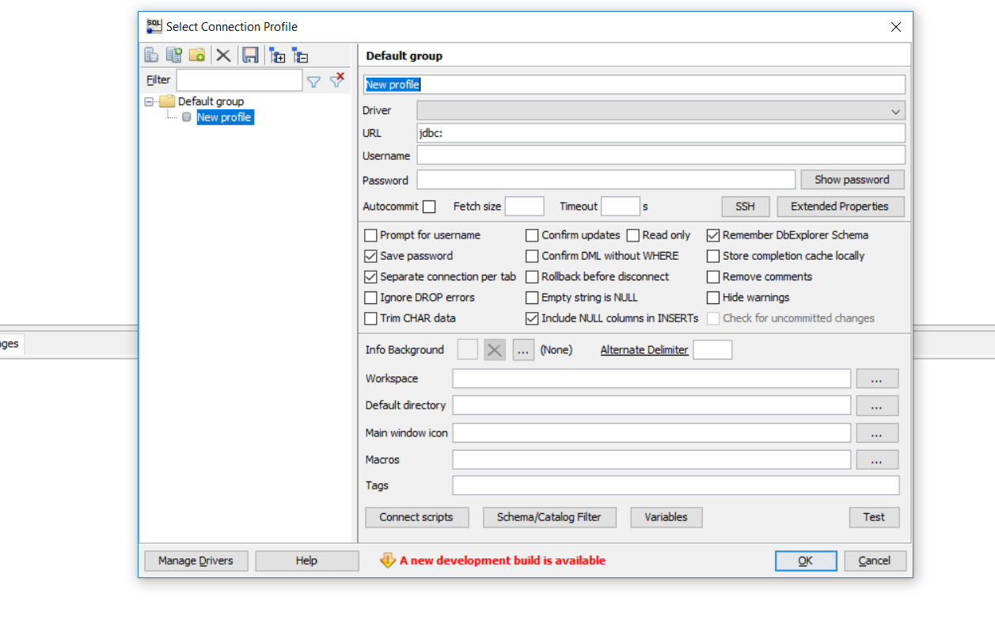

IMG 3.1

* Create a new driver following IMG 3.2

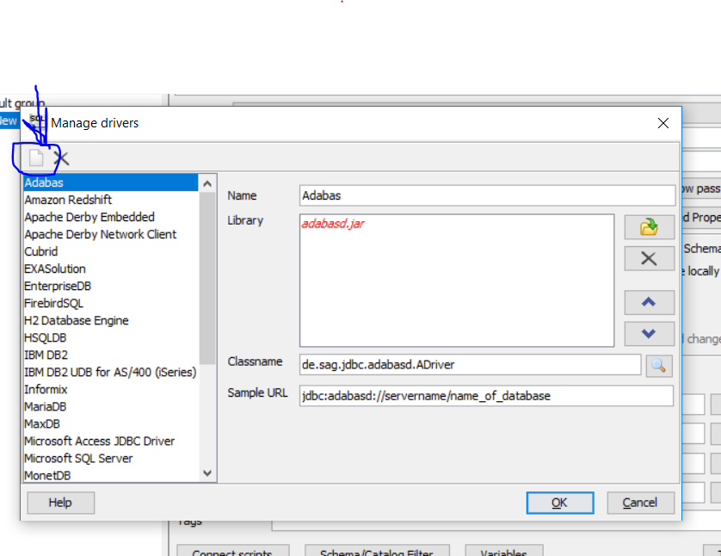

IMG 3.2

* Put in the name as “RedShift” inside the Name field and click on the “Location Icon” shown in IMG 3.3 marked Browse to the location where you have saved your **JDBC Jar file,** select the **.jar file** and click ok. (This is the file that we downloaded while configuring our Amazon Redshift cluster)

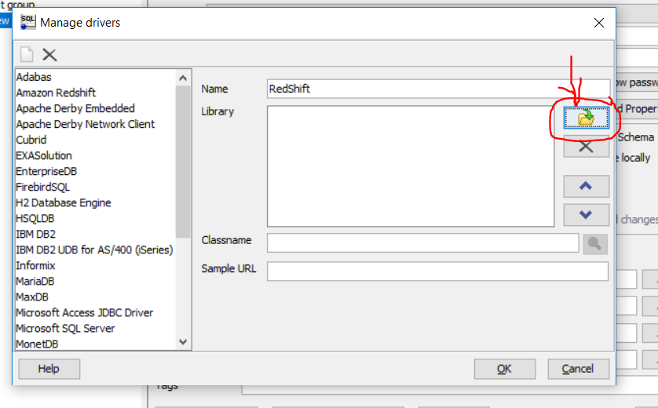

IMG 3.3

Step4- After you successfully configured your JDBC driver with SQL Workbench. You would get the following screen-

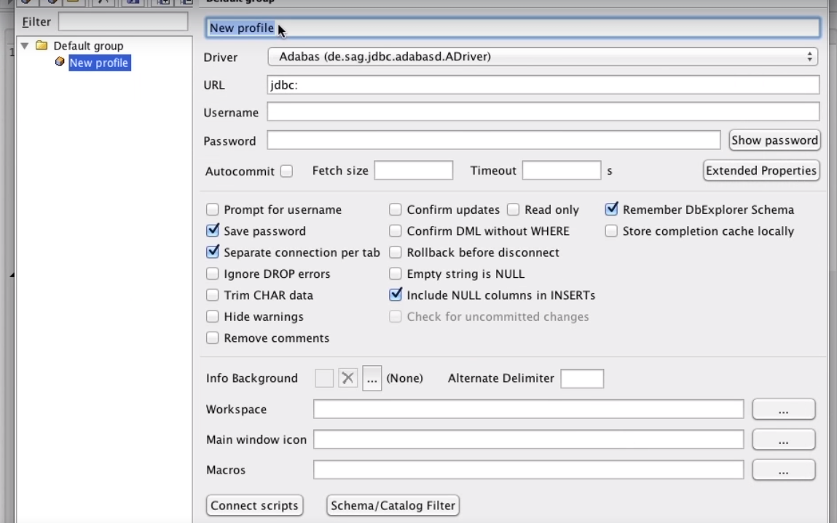

IMG 4.1

Please set the following parameters as follows-

* Write any name in the field where you see New Profile for e.g. RedShift
* For Driver, because you have configured your SQL workbench with JDBC driver, you should be able to see Redshift JDBC when you would click on the dropdown box
* Under the URL, please put in the link from cluster (When you go to your cluster details in AWS, you can find that link from there)
* Username- It is the username that you used before setting up the cluster
* Password- It is the password that you have saved before setting up the cluster.

Please refer the following IMG 4.2 for more clear understanding

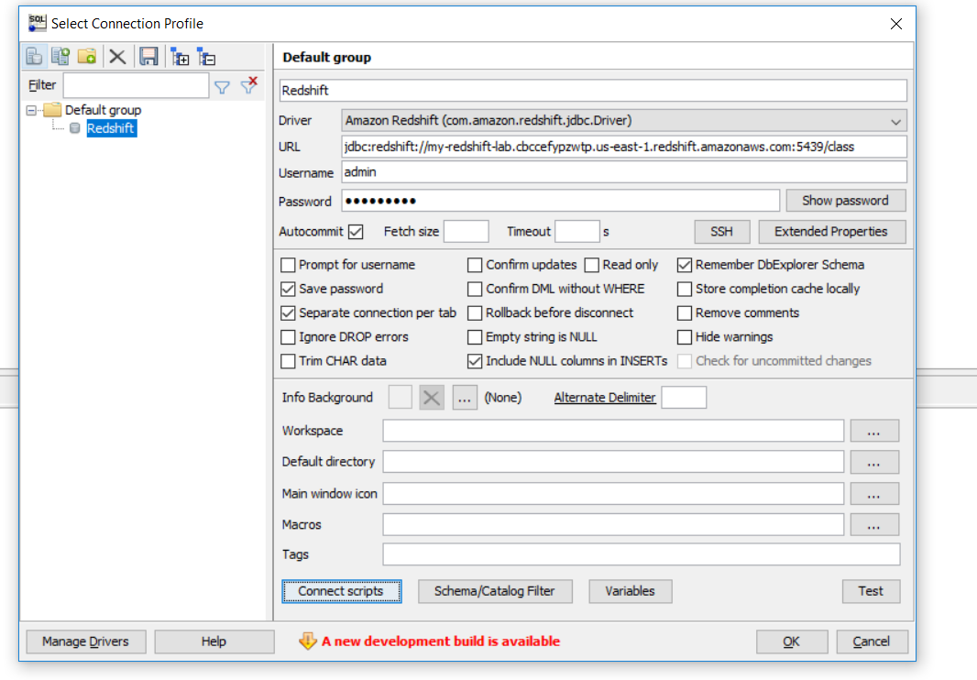

IMG 4.2

Step5- **Connect Scripts**

Click on **Connect Scripts** as shown in IMG 5.1

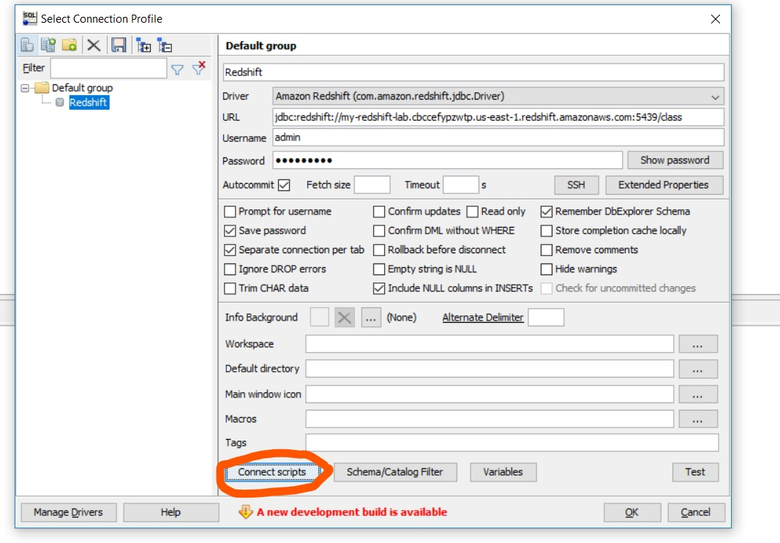

IMG 5.1

A screen like this would appear

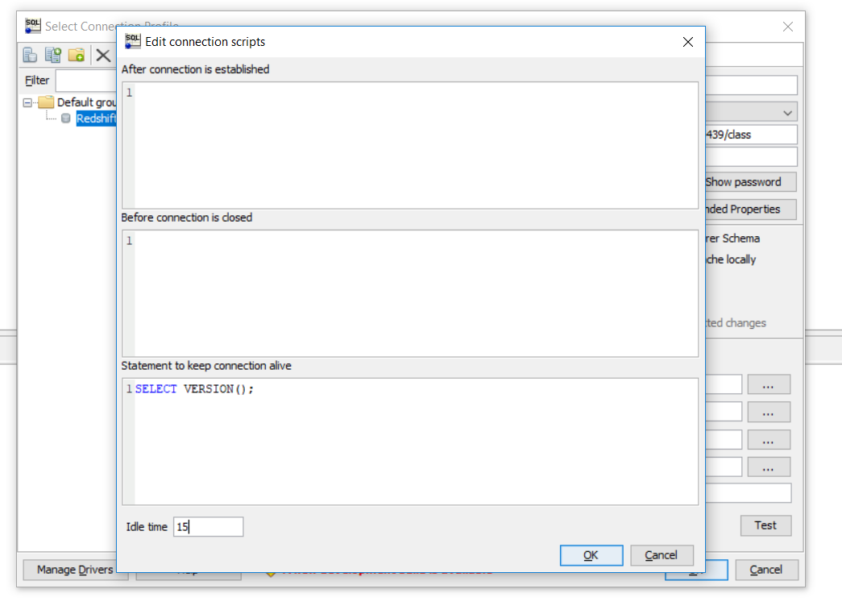

IMG 5.2

* Under the third block “**Statement to keep connection alive**” put in the following script-

**SELECT VERSION();**

* Fill in the **Idle Time** field as **15** seconds
* Click OK

After the connection is established, you should be able to see a green check mark besides “**Connect Scripts**” as shown in IMG 5.3

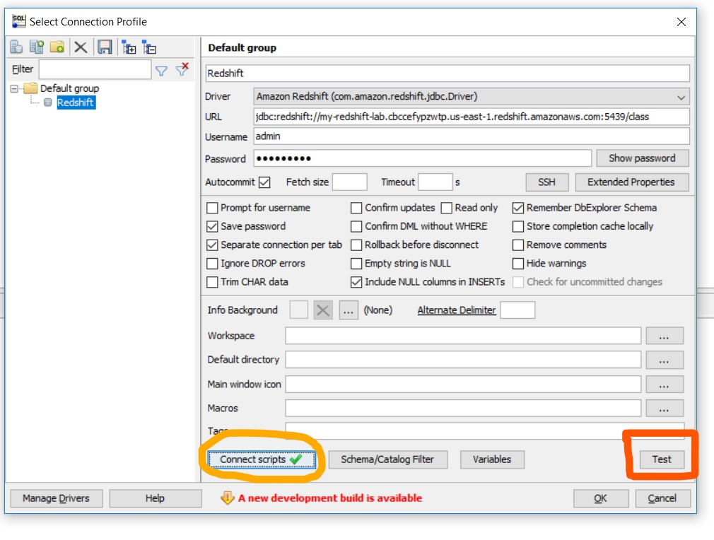

IMG 5.3

* You can also verify the success of the connection by clicking “Test”
* A dialog box with message saying “Connection is successful will pop up”

Step6- **Saving the Profile**

Before you exit “SQL Workbench”. Make sure you have saved your profile with save button at top, as shown in IMG

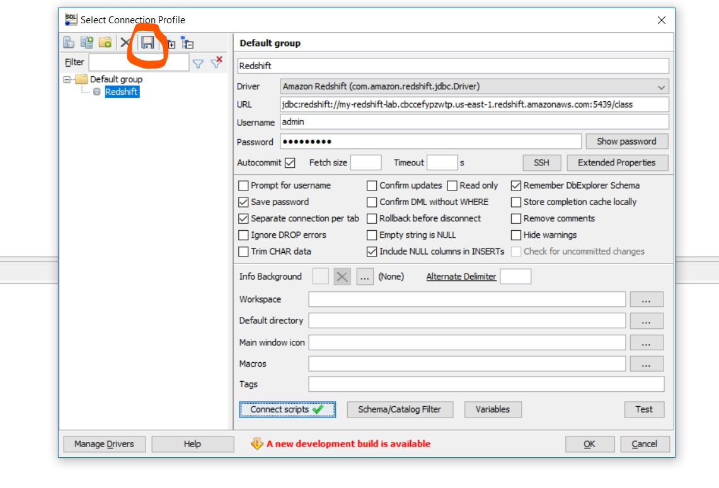

Now you freely exit your application without any stress!

Congratulations! You have crossed another hurdle!!